**【答疑】常見問題匯總**

同學們，大家好！歡迎大家選修實驗室科研探究課程。本文檔匯總了以往選修探究課的同學常見的或關注的一些問題。在選修本課程期間如有問題，建議先查閱本文檔，如有不在此文檔的其他問題，歡迎聯繫我們。

### （一）資訊獲取

1、  **所有課程教學單元的上課時間和地點？單元老師的聯繫方式？**

答：在網路學堂課程檔中下載重要檔匯總（課程檔序號為0），其中有“【登記表】2022-2023年春季學期實驗室科研探究課教學單元資訊”檔和課程地圖檔，其中包含所有教學單元的上課地點詳細資訊、時間及負責教師的聯繫電話及郵箱。考勤表背面也有上課地點供快速查詢。

2、  **講座課及其上課地點？**

答：本學期講座課包括第125、128單元。講座課程的上課時間已經確定，上課地點會提前一周確定好在網路課堂的課程公告中通知同學們。講座課向所有選課同學公開，沒有選講座單元的同學也可以參加，獲得有效考勤。

3、  **XX樓XX教室在哪裡？**

答：登記表中有上課教室詳細資訊，可以通過地圖軟體查找，進樓時可詢問門衛。或在網路學堂-課程檔中下載“上課地點地圖”查找。如果還找不到，請致電詢問對應教學單元的負責老師。

### （二）二級選課

1. **每個單元有多個時間段，要怎麼選課？一共要選多少課？**

答：（1）每個單元各個時間段課程內容相同，每個單元僅需選擇一個大節的時間段，上一次課。

（2）一共需要上夠8個單元。（第一次選課建議上概論課+7個其它單元）

1. **選錯了如何刪除二級課程？**

答：第一步：上方下拉清單中選擇需要刪除的單元

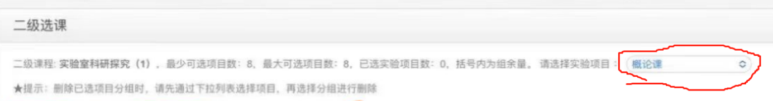

第二步：下拉到全部已選課程表格中，需要刪除單元前面出現待選框，勾選待選框，並提交 即可刪除該單元課程

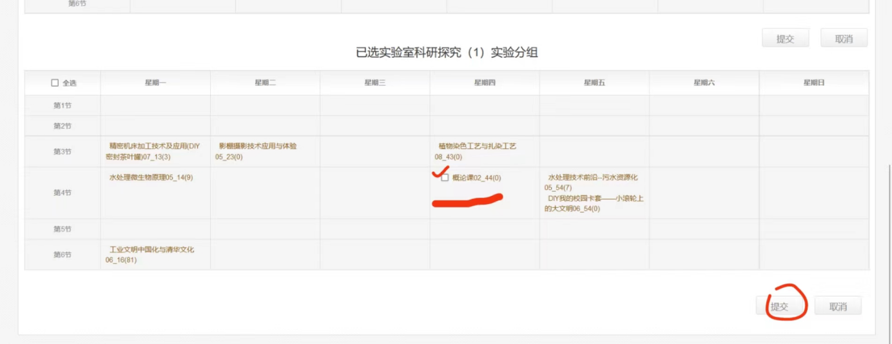

### （三）考勤考核

6、  **滿足哪些條件可以獲得課程通過？**

答：（1）8次考勤。上滿8次課（概論課計為1次），獲得8次有效考勤，期末交考勤表到李兆基樓信箱；

（2）9個作業。提交如下作業：①在上課的8個單元視窗分別提交對應的學習日誌；②在“學習日誌匯總”作業視窗按作業要求提交日誌匯總。

7、  **課程成績是績點還是P/F?**

答：探究課是P/F課程，最終成績為“通過”或“不通過”。

8、  **未選或未上概論課怎麼辦？之前選過概論課還要選嗎？**

答：如果未選上概論課，也是可以來上概論課的，並記錄為有效考勤，上課時間和地點請關注網路學堂公告和微信群消息。如果因各種原因無法上概論課，可以用其他教學單元替代。如果在之前學期選修過探究課的概論課，則不需要也不能再選概論課。

9、  **選課階段在二級選課裡沒有選到8個教學單元，有什麼辦法嗎？課程衝突或因其他事情，想選擇其他單元怎麼辦？錯過上課時間，總量不夠8個怎麼辦？**

答：可以用講座或其他單元替代或補齊：

（1）講座課不用申請，直接去上課就可以；

（2）訓練中心的單元課程不需要和老師申請確認，直接去上課就可以；

（3）如果有自己心儀的其他實驗室教學單元，可以和該教學單元老師發郵件聯繫，在征得其同意後，也可以用該教學單元來替代。

10、  **探究課1、2、3、4有區別嗎？**

答：這四個課程是獨立的。第一次選課的話，選哪一個都可以；第二次選探究課的話，就請選之前沒選過的。

11、  **沒有出成績之前，怎麼確認自己是否通過？**

答：對未達到通過要求的同學，助教會一一聯繫確認。對通過考核要求的同學一般不做回饋。

### （四）關於考勤表

12、  **如何獲取考勤表？**

（1）概論課的課前會集中發放考勤表，概論課上課期間也可以領取考勤表；

（2）在課後到李兆基樓B338鐘老師領取，通常考勤表會放在B338辦公室門前的架子上；

（3）網路學堂課程檔中有考勤表的電子版，可以自行下載列印。

13、 **考勤表丟失了怎辦？**

答：建議同學們每上一次課就拍照記錄一下，如丟失考勤表，和助教聯繫提供照片證明即可，新考勤表可以自己列印或到李兆基樓B338找鐘老師領取，不需要補蓋章。如果沒有上課證明，則需要找對應課程老師補蓋。

14、**如果上課未帶考勤表，怎麼辦？**

答：請將考勤章蓋到一張白紙上，期末交考勤表時，一併上交（用釘書機將白紙和考勤表訂在一起）。

15、**上完課忘記蓋章怎麼辦？**

答：同學們可以找相應課程老師補蓋。如果老師無法給同學們補蓋章，同學們可以聯繫助教說明情況，並在考勤表相應位置上注明一下該單元課的情況（包括課程號、課程名稱、原因和聯繫電話）。

16、**考核表提交到哪裡？最遲什麼時候提交？**

答：李兆基科技大樓基礎工業訓練中心5層的探究課程信箱處（正對著電梯），有3個信箱均可以交。提交截止時間和日誌匯總ddl相同。

視頻導航：<https://easylink.cc/t10ev0>

17、**怎麼看自己的考勤表交了沒有？**

答：如果考核表提交了且沒有問題，我們一般不會作回饋。

18、**如果同時選了多門探究課，是否可以在多個表上蓋一個課的章？**

答：不可以，同一個學生不允許出現兩個一樣的教學單元章。不同探究課考勤表上的章必須不同，或者說選了N個探究課，必須要保證有總計8*N個各不相同單元課的章，且每個表上不得少於8個章。

### （五）關於作業

19、**需要提交哪些作業？**

（1）在上課的8個單元視窗分別提交對應的學習日誌；

（2）在“學習日誌匯總”作業視窗按作業要求提交日誌匯總。

20、**作業提交中為什麼要“建議word版本為2003及以下”？**

答：因為word版本是向下相容的，考慮到有些實驗室的電腦（老師批改作業用）的word版本可能比較低，擔心版本過高的話老師可能打不開，而幾乎所有系統都可以打開經典03版本word，因此保險起見還請同學們盡可能另存低版本檔，以防出現打不開的情況。具體操作方法為：文檔另存為，保存類型選擇“Word 97-2003文檔(*.doc)”。

21、**日誌集合是什麼？**

答：請參考作業附件中的日誌匯總範本。將八次課的日誌放進一個word檔裡，再在該word文檔結尾處對本學期的探究課程做一個整體性的學習總結，約200字左右。

22、**“究”作業是什麼？**

答：在第8周“探”階段結束後，個別單元還將試點加強“究”，有意在某學科深入“究”的同學請及時關注網路學堂公告欄，進行深入研究，作業在“究”一欄提交。“究”環節由同學們自由自願選擇，不計入成績。

23、 **錯過了網路學堂上作業的ddl怎麼辦？**

答：可以補交到實驗室探究課工作郵箱（tjk@mail.tsinghua.edu.cn），收到回復後提交成功。

### （六）常問單元上課位址

1. **航院風洞實驗室在哪裡（29單元《風洞在飛行器研製過程中的應用》）？**

視頻導航：<https://easylink.cc/wj3wv2>

在校園東北角，東北門南側約70米：

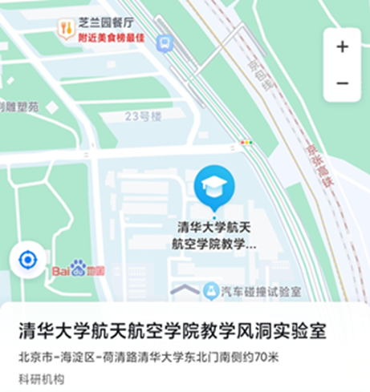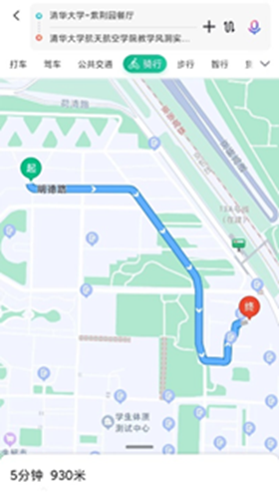

25、 **能動系館在哪裡（33單元《煤炭潔淨高效轉化與利用》）?**

在二校門東側：

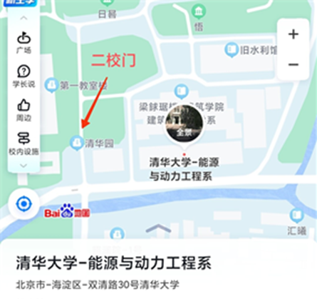

26、**工物系舊館在哪裡？（10單元）**

工物系舊館，可通過地圖搜索“工物館”

具體位置如下圖

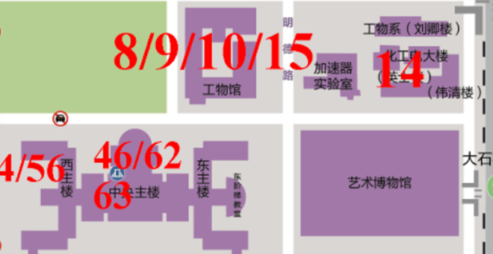

27、**87單元消失模鑄造單元教室怎麼走？（87單元）**

從東北門進，右拐進電梯，直接到地下四層，有路標指標，沿著指標路標走就可以到87單元即消失模鑄造單元教室。

視頻導航：<https://easylink.cc/2trzxc>

28、**15單元-走進化學工程國家重點實驗室位址中的擴工物館在哪？**

擴工物館即工物館，上課教室需由工物館東北門進，坐電梯到六層，再步行上到七層，右轉到711。

視頻導航：<https://easylink.cc/z00aqn>

29、**醫學樓D區在哪？**

校醫院過橋就是 鄭裕彤醫學樓 東門

視頻導航：<https://easylink.cc/t1aj0b>

30、**逸夫技科樓1204怎麼去？**

1代表1區，2代表2樓，需要進入大門之後先通過電梯下一樓，找到1區，從另一個電梯上二樓

視頻導航：<https://easylink.cc/l35yr0>

31、**李兆基BDxxx怎麼走？**

從iCenter進入然後去地下，例如BD222（進入iCenter後，下地下二層）

視頻導航：<https://easylink.cc/fferbc>

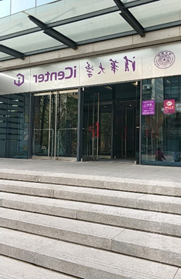（iCenter）

32、 醫學影像中心怎麼走？

視頻導航：<https://easylink.cc/79flk4>

## Common Issues in the Fall 2024 Semester Laboratory Research Course

Hello, everyone! Welcome to the Laboratory Research Course. This document compiles some common questions and concerns that previous students have had. If you encounter any issues during the course, we recommend checking this document first. If your question is not covered here, feel free to contact us.

### Information Access

1. **What are the class times and locations for all course units? How can I contact the unit instructors?**
   * + Answer: You can download the "Important Documents Summary" (course file number 0) from the online learning platform. This includes the "Registration Form for the Spring Semester 2022-2023 Laboratory Research Course Units" and the course map file, which contain detailed information about class times, locations, and contact details (phone and email) for the instructors. The attendance sheet also has the class locations for quick reference.
2. **What about lecture classes and their locations?**
   * + Answer: This semester, lecture classes include units 125 and 128. The times for these lecture classes have been set, and the locations will be announced a week in advance on the course announcement section of the online learning platform. Lecture classes are open to all enrolled students, even if you haven't selected these specific units, and attending them counts towards your attendance.
3. **Where is room XX in building XX?**
   * + Answer: The registration form includes detailed information about classroom locations. You can use a map app to find the building and ask the security guard for directions when you arrive. Alternatively, you can download the "Classroom Location Map" from the online learning platform under course files. If you still can't find it, please call the instructor responsible for the relevant course unit.

**Secondary Course Selection**

1. **How do I choose class times if there are multiple time slots for each unit? How many classes do I need to take in total?**
   * + Answer:The content for each unit is the same across different time slots. You only need to choose one time slot for each unit and attend that session.You need to complete a total of 8 units. (For your first selection, it is recommended to take the introductory course plus 7 other units.)
2. **How can I delete a secondary course if I selected the wrong one?**
   * + Answer:

* First, select the unit you want to delete from the dropdown menu at the top.

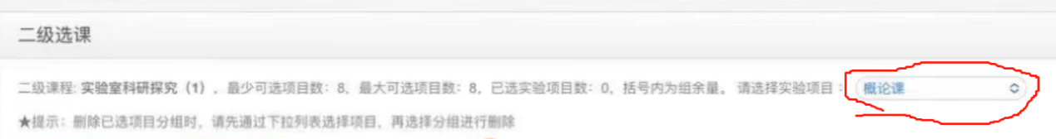

* Scroll down to the table of all selected courses, check the box in front of the unit you want to delete, and submit. This will remove the selected unit.

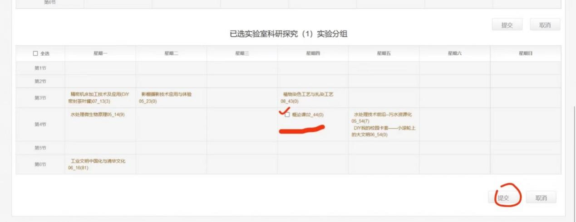

### Attendance and Assessment

1. **What are the requirements to pass the course?**
   * + Answer:

Attend 8 sessions. You need to attend a total of 8 classes (the introductory course counts as one session) and submit the attendance sheet to the mailbox at the Lizhaoji Building at the end of the term.

Complete 9 assignments. Submit the following assignments:

Submit a learning log for each of the 8 units you attend.

Submit a summary of these logs in the "Learning Log Summary" assignment window as per the requirements.

1. **Is the course graded by GPA or P/F?**
   * + - Answer: The research course is a Pass/Fail (P/F) course. The final grade will be either "Pass" or "Fail."
2. **What if I haven't selected or attended the introductory course? Do I need to select it again if I have already taken it?**
   * + - Answer: If you haven't selected the introductory course, you can still attend it and it will count as valid attendance. Please check the online learning platform announcements and WeChat group messages for the time and location. If you can't attend the introductory course for any reason, you can replace it with another unit. If you have taken the introductory course in a previous semester, you do not need to (and cannot) select it again.
3. **What if I didn't select 8 teaching units during the secondary course selection phase? What if there is a schedule conflict or other issues, and I want to choose different units? What if I missed class sessions and don't have enough to total 8?**
   * + - **Answer:** You can replace or make up the units with lectures or other units:

You don't need to apply for lecture classes, just attend them.

For Training Center units, you can attend without needing the instructor's confirmation.

If you have a preferred laboratory teaching unit, you can email the instructor for permission. If they agree, you can use that unit as a replacement.

1. **Is there a difference between Research Courses 1, 2, 3, and 4?**
   * + - Answer: These four courses are independent of each other. If you are selecting a research course for the first time, you can choose any one of them. For your second time, please choose one you haven't taken before.
2. **How can I confirm if I have passed before the final grades are released?**
   * + - Answer: The teaching assistants will contact students who do not meet the passing requirements individually for confirmation. Generally, no feedback is given to students who have met the requirements.

### About the Attendance Sheet

1. **How can I obtain the attendance sheet?**
   * Answer:
     + - Attendance sheets will be distributed before the introductory class and can also be collected during the introductory class.
       - After class, you can collect them from Teacher Zhong at Room B338 in the Lizhaoji Building. Usually, the attendance sheets are placed on a rack in front of Room B338.
       - An electronic version of the attendance sheet is available in the course files on the online learning platform. You can download and print it yourself.
2. **What should I do if I lose my attendance sheet?**
   * Answer: It's recommended to take a photo of the attendance sheet after each class. If you lose your attendance sheet, contact the teaching assistant and provide the photo proof. You can print a new attendance sheet yourself or get one from Teacher Zhong at Room B338. There is no need to get it re-stamped. If you don't have proof of attendance, you'll need to get the stamp from the corresponding course instructor.
3. **What if I forget to bring my attendance sheet to class?**
   * Answer: Stamp a blank piece of paper during the class and staple it to your attendance sheet when you submit it at the end of the term.
4. **What if I forget to get my attendance sheet stamped after class?**
   * Answer: You can ask the course instructor to stamp it later. If the instructor is unable to do so, contact the teaching assistant, explain the situation, and note the course details (including course number, course name, reason, and contact information) in the corresponding section of the attendance sheet.
5. **Where and when should I submit the attendance sheet?**
   * Answer: Submit it to the research course mailbox on the 5th floor of the Basic Industrial Training Center in the Lizhaoji Technology Building (directly facing the elevator). There are three mailboxes, and you can use any of them. The submission deadline is the same as the learning log summary deadline. Video navigation: <https://easylink.cc/t10ev0>
6. **How can I check if my attendance sheet has been submitted?**
   * Answer: If the attendance sheet has been submitted and there are no issues, we generally do not provide feedback.
7. **If I have enrolled in multiple research courses, can I use the same class stamp on multiple sheets?**
   * Answer: No, the same student cannot use the same unit stamp on multiple sheets. Each attendance sheet for different research courses must have different stamps. If you have enrolled in N research courses, you must have a total of 8*N unique unit stamps, with each sheet having no less than 8 stamps.

### About Assignments

1. **What assignments need to be submitted?**
   * Answer:
     + - Submit a learning log for each of the 8 units attended in the corresponding unit's submission window.
       - Submit a summary of these logs in the "Learning Log Summary" assignment window according to the assignment requirements.
2. **Why is it recommended to submit assignments in "Word 2003 or earlier" format?**
   * Answer: Word documents are backward compatible. Some laboratory computers (used by instructors for grading) may have older versions of Word, and higher versions might not open correctly. Almost all systems can open the classic 2003 version, so to ensure compatibility, please save your files in a lower version format. To do this: save the document as "Word 97-2003 Document (*.doc)".
3. **What is the log summary?**
   * Answer: Refer to the log summary template provided in the assignment attachments. Combine the logs from the eight classes into one Word document and include an overall summary of the research course for the semester, approximately 200 words, at the end of the document.
4. **What is the "Research" assignment?**
   * Answer: After the "Exploration" phase ends in the 8th week, some units will pilot an enhanced "Research" phase. Students interested in deepening their research in a specific subject should check the online learning platform's announcements and submit their research in the "Research" section. Participation in this phase is voluntary and does not count towards the final grade.
5. **What should I do if I miss the assignment deadline on the online learning platform?**
   * Answer: You can submit the assignment to the Laboratory Research Course work email (tjk@mail.tsinghua.edu.cn). Once you receive a reply, your submission is considered successful.

### Frequently Asked Class Locations

1. **Where is the Aeronautics Wind Tunnel Laboratory (Unit 29: "Application of Wind Tunnels in Aircraft Development")?**
   * Answer: The Aeronautics Wind Tunnel Laboratory is located in the northeast corner of the campus, about 70 meters south of the Northeast Gate. For a video navigation guide, please visit https://easylink.cc/wj3wv2

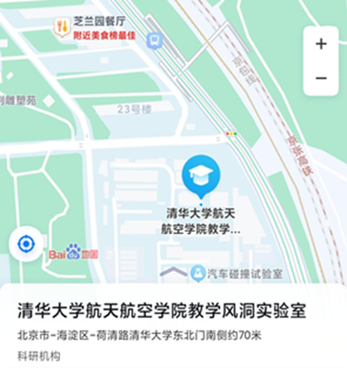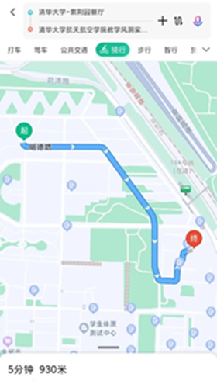

1. **Where is the Energy and Power Engineering Building (Unit 33: "Clean and Efficient Coal Conversion and Utilization")?**
   * Answer: The Energy and Power Engineering Building is located east of the Second School Gate.
   * 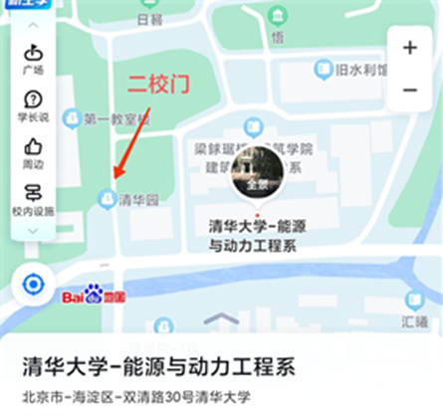
2. **Where is the old Engineering Physics Building (Unit 10)?**
   * Answer: The old Engineering Physics Building, also known as the Gongwu Building, can be found using map search "Gongwu Building." Refer to the following image for the exact location.

* 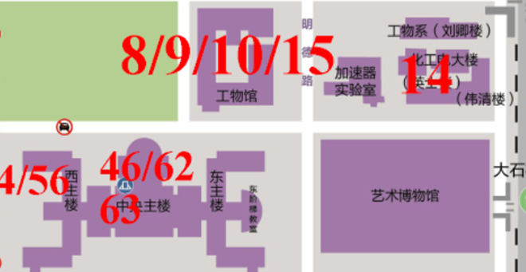

1. **How to get to the Lost Foam Casting Unit Classroom (Unit 87)?**
   * Answer: Enter through the Northeast Gate, turn right to take the elevator directly to the B4 level. Follow the signs to the Unit 87 classroom (Lost Foam Casting Unit). For a video navigation guide, please visit <https://easylink.cc/2trzxc>.
2. **Where is the Kuogongwu Building for Unit 15: "Introduction to the State Key Laboratory of Chemical Engineering"?**
   * Answer: The Kuogongwu Building is the same as the Gongwu Building. Enter from the northeast gate of the Gongwu Building, take the elevator to the 6th floor, then walk up to the 7th floor, turn right to room 711. For a video navigation guide, please visit <https://easylink.cc/z00aqn>.
3. **Where is the D Area of the Medical Building?**
   * Answer: The D Area of the Medical Building is located just across the bridge from the campus hospital at the East Gate of the Cheng Yu Tung Medical Building. For a video navigation guide, please visit <https://easylink.cc/t1aj0b>.
4. **How to get to Room 1204 in the Yifu Science and Technology Building?**
   * Answer: "1" indicates Area 1, and "2" indicates the 2nd floor. After entering the main gate, take the elevator to the 1st floor, find Area 1, then take another elevator to the 2nd floor. For a video navigation guide, please visit <https://easylink.cc/l35yr0>.
5. **How to get to BDxxx in the Lizhaoji Building?**

* Answer: Enter from iCenter and go underground. For example, for BD222, enter iCenter and go to the B2 level. For a video navigation guide, please visit <https://easylink.cc/fferbc>.
* 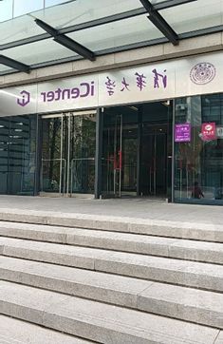

1. **How to get to the Medical Imaging Center?**

* Answer: For a video navigation guide, please visit <https://easylink.cc/79flk4>.